MAP COLORING PROBLEM

NAME: J.L.PUGAZH MUKILAN

REG NO: 22BCE9292 SLOT :L7+L8

1)Solve the map coloring problem in artificial intelligence

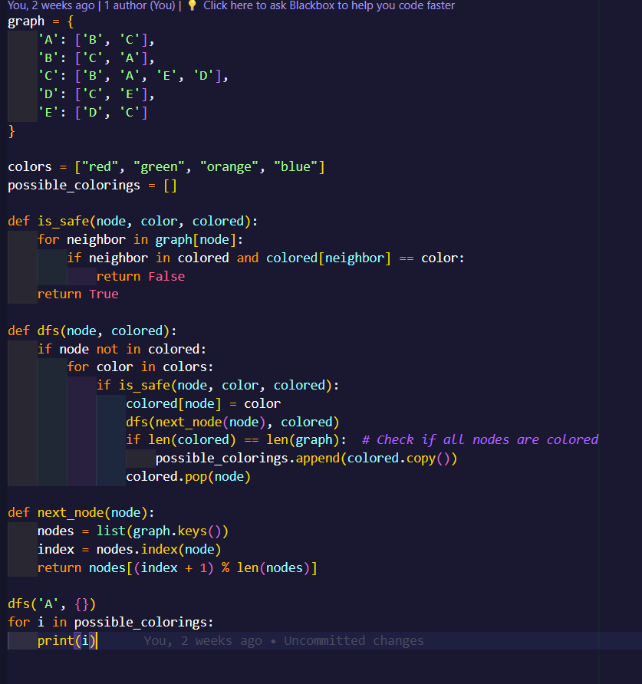

OUTPUT:

